1. Create a Blog Using Blogspot Customize the theme Design and post new Article with 500 words

Welcome to my Blogspot blog, where I explore a diverse array of topics and share my passions, insights, and experiences. Whether it's travel adventures, culinary discoveries, tech trends, or lifestyle advice, I'm here to inspire, inform, and entertain. Join me on this exciting journey of discovery and discussion, as we navigate the intriguing landscape of the digital world.

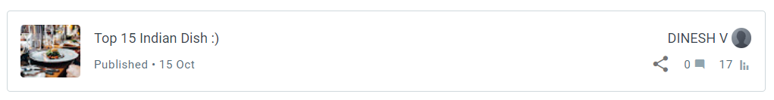

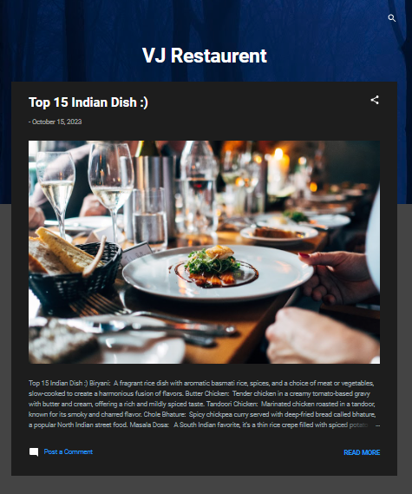

VJ Restauran: <https://vjrestaurent.blogspot.com/2023/10/top-15-indian-dish.html>

1. Create a New Facebook Business Page and Post one Social media Poster for your Brand

our new Facebook Business Page! We're dedicated to delivering excellence. Stay updated on our latest products, promotions, and more. Check out our stunning social media poster showcasing our brand's essence. Join us in this journey.

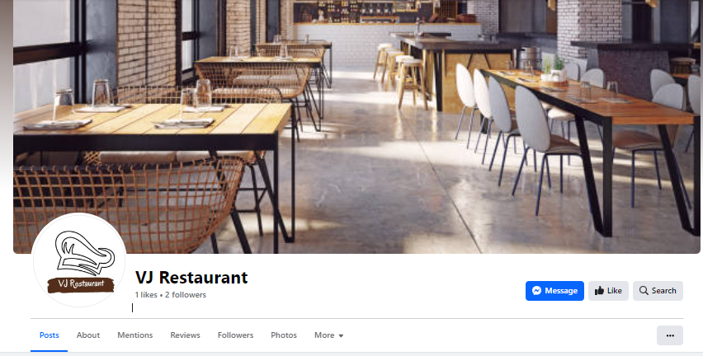

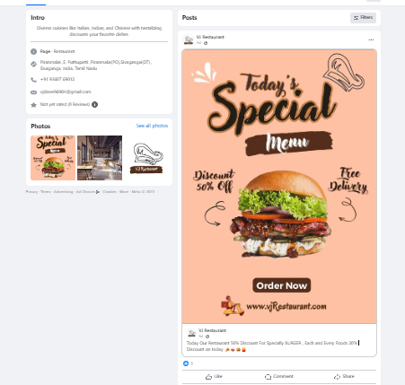

Facebook Business VJRestaurant: [https://www.facebook.com/people/VJRestaurant/61552042277060/](https://www.facebook.com/people/VJ-Restaurant/61552042277060/)

1. Create and Design a social media advertisement poster using Canva

Welcome to VJ Restaurant - A Culinary Paradise!

Welcome to VJ Restaurant - A Culinary Paradise!

Indulge in a gastronomic journey like no other. Our restaurant is a haven for food enthusiasts seeking a symphony of flavors and exceptional dining experiences. With a menu meticulously crafted to satisfy every palate and a warm, inviting ambiance, we promise to deliver unforgettable moments in every bite. Join us for a taste of excellence at VJ Restaurant, where culinary dreams come true.

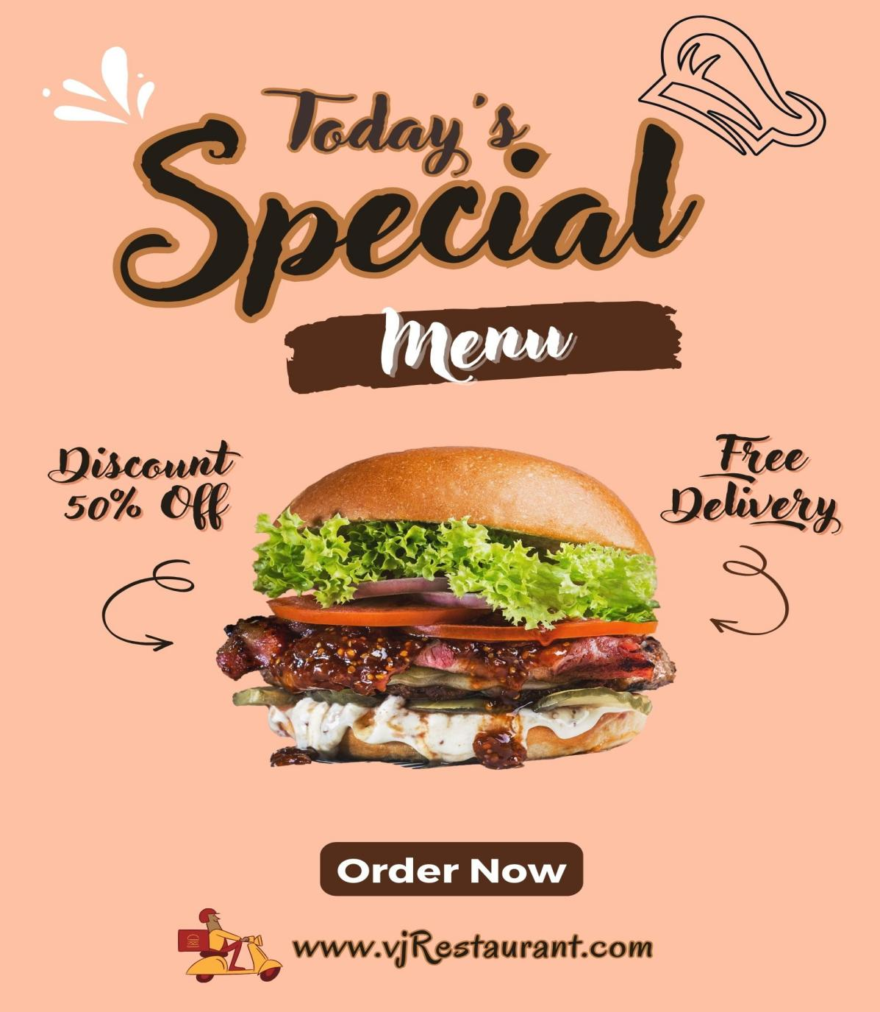

1. Create Email Newsletter Design Using Canva Tool

We are thrilled to introduce VJ Restaurant, your newest destination for exceptional dining experiences. Immerse yourself in a world of delectable flavors, where every dish is a work of art. Our restaurant combines culinary expertise with a warm and inviting ambiance, promising unforgettable moments with every bite. Stay connected with us for exciting updates, special promotions, and exclusive events. Join us in making your culinary dreams a reality!

